**Homework #1  
High Dynamic Range Imaging**

*Assigned on March 13, 2024*

***Due by April 3, 2024***

**2.1 Exploration (20%)**

1. A conceptual figure Figure 3 shows how bracketing images can recover the radiance of a scene. What is the meaning of this figure? Try to plot the same figure for memorial image set and describe how you plot the figure. **(5%)**

For the Figure1, I just simply sample 3(*adjusted parameters*) identical pixels (i, j) from original memorial images and draw their pixel value from T1 to Tn. (n: number of pictures under different exposure times)

As for the Figure2, I also take the sample pixels (i, j) from previous stage and assign it to my radiance function g(zij) as x-coord of figure and its corresponding pixel value as y-coord.

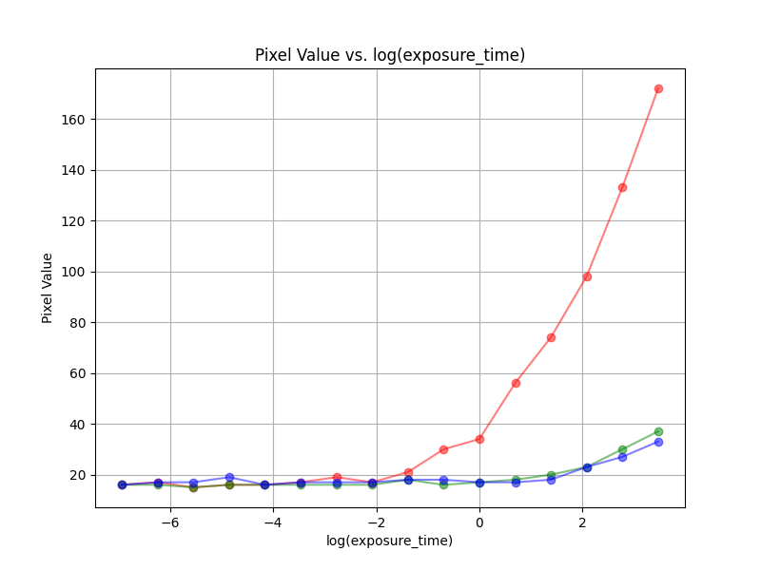 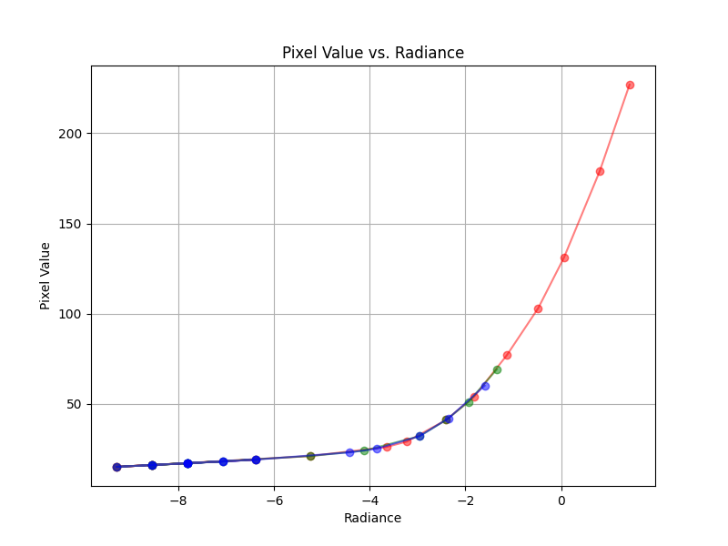

Figure2

Figure1

Here we can see that after we add the smoothness term as our objective function, Figure2 is smooth.

1. At the step of local tone mapping, why bilateral filter can eliminate halo effect, but gaussian filter cannot? **(5%)**

The key difference between bilateral and Gaussian filters lies in their consideration of spatial and intensity differences:

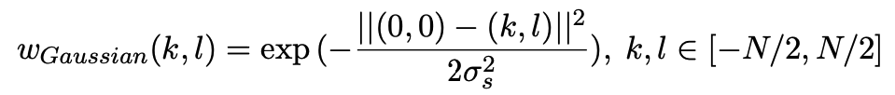

Gaussian filter

The Gaussian filter only considers spatial distance when calculating the weights for averaging pixel values. It applies a uniform weight to all neighboring pixels within the specified radius.



Bilateral filter

On the other side, bilateral filter considers both spatial distance and intensity difference when calculating the weights for averaging pixel values. It applies higher weights to pixels that are close in spatial distance and have similar intensity values. By doing so, it preserves edges while smoothing the image.

To sum up, because the bilateral filter's ability to consider both spatial and intensity differences, which allows it to better preserve edge details while reducing noise, making it more effective in eliminating the halo effect during local tone mapping in HDR image processing compared to the Gaussian filter.

1. Create your own HDR image. Photograph a bracketing set of exposures for a designed scene and perform the HDR imaging flow. Generate at least three HDR images using differnet tone mapping methodology in the flow. i.e. Run the flow with global tone mapping, local tone mapping with gaussian filter, and local tone mapping with bilateral filter. Provide at least the following information in your report. **(10%)**

I take my candidate HDR image in two space(taken by different cell-phone): 1. 台達大門口的大樹 (晚上室外) 2. 宿舍房間 (白天室內) to compare HDR result **under different light condition**. I choose the scene of strong contrast between light and dark to see the effect of HDR image. Due to the space limit, I’ll put my bracketing image in the *Appendix*, here I only provide my own HDR result.

1. Delta main entrance (night/ streetlamp /outdoor)

Camera setting:

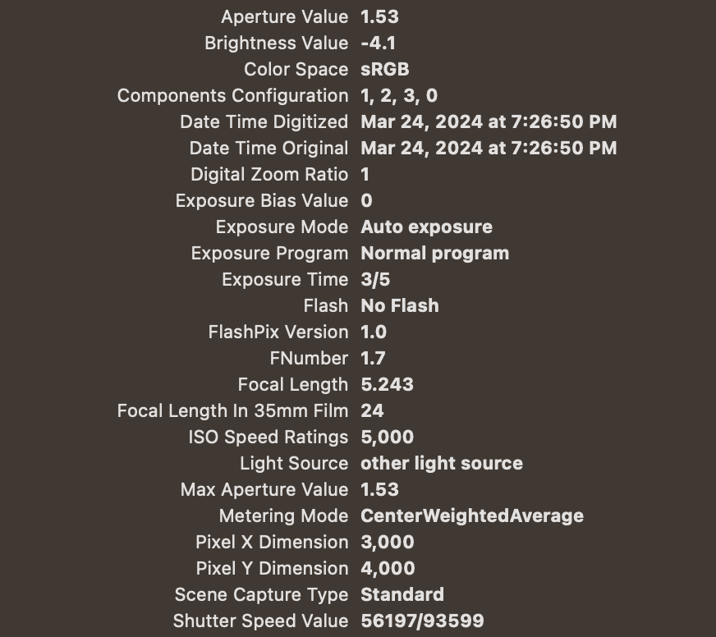

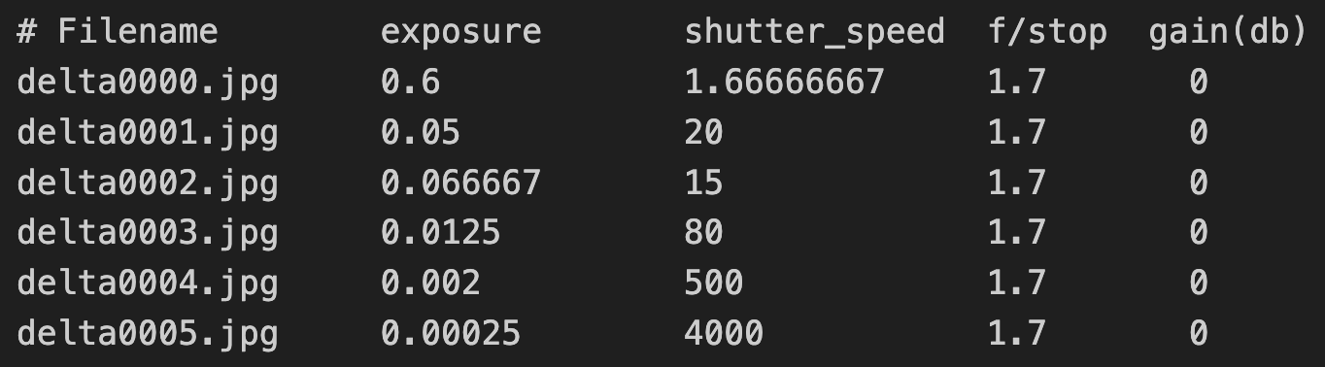

  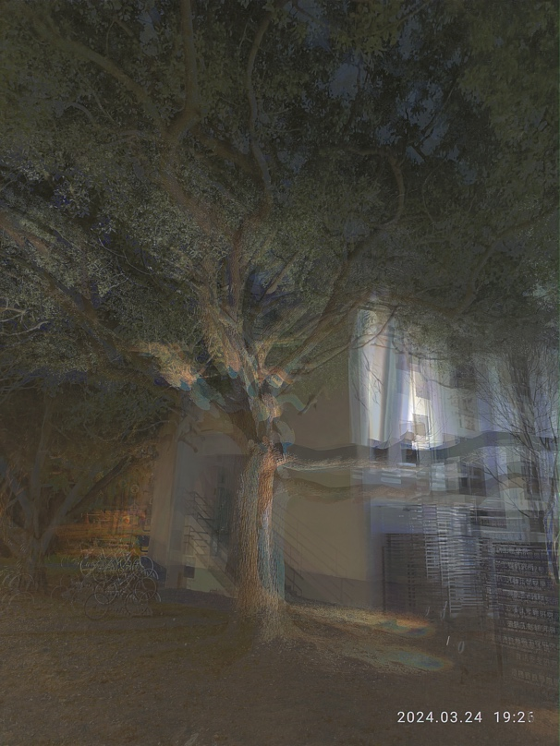 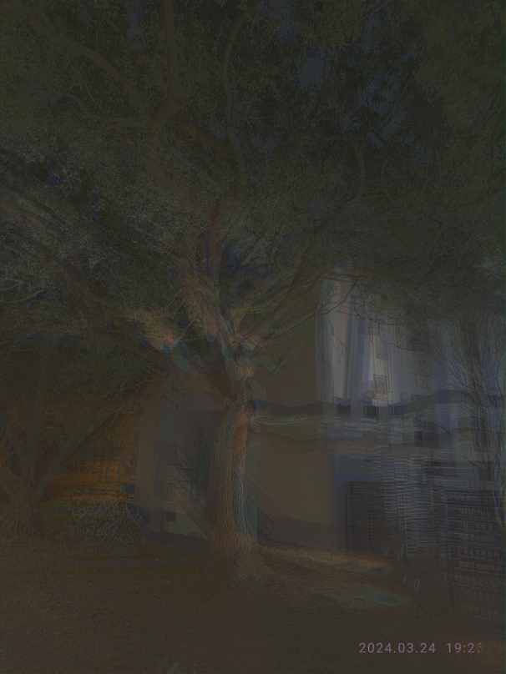

Figure6 w/ WB + LocalTM (bi)

Figure5 w/ WB + LocalTM (gau)

Figure4 w/ WB

Figure3 w/o WB

It was my first HDR image bracket and it’s a lot of hand shaking... (looks scary btw) We can observe that image w/ white (Figure4) balance is much more lighten than w/o (Figure3) ones, I think it may be due to hand shaking, so the white region isn’t the same in each image. Thus, lead to poor result. After adding local tone mapping (Figure5,6), the result become much better, and the gaussian filter also **leads to glow region where bilateral fix this problem by considering the distance term**.

1. In the room (daytime/desk lamp/indoor)

Camera setting:

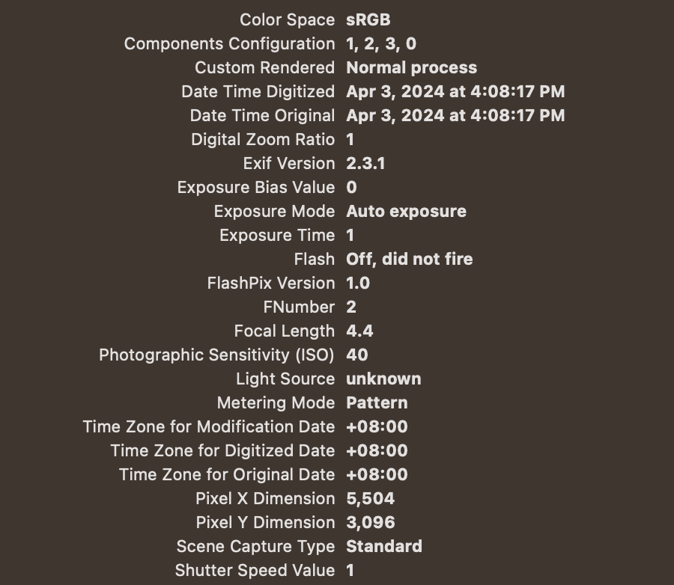

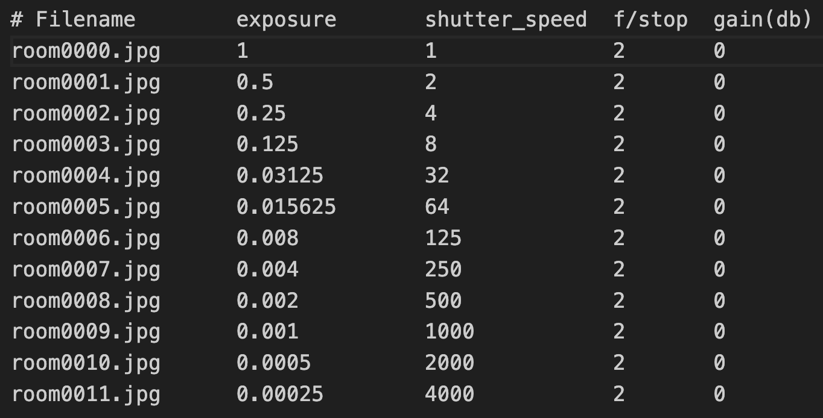

 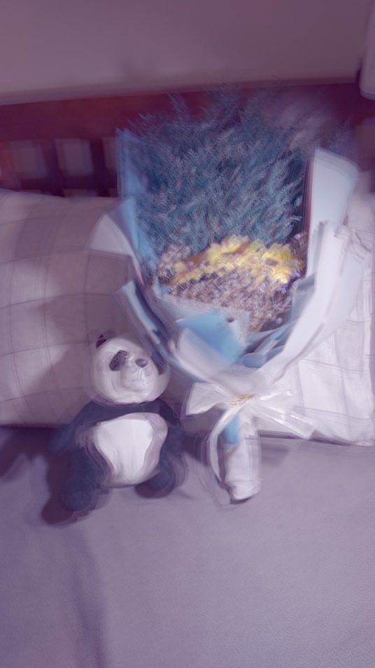 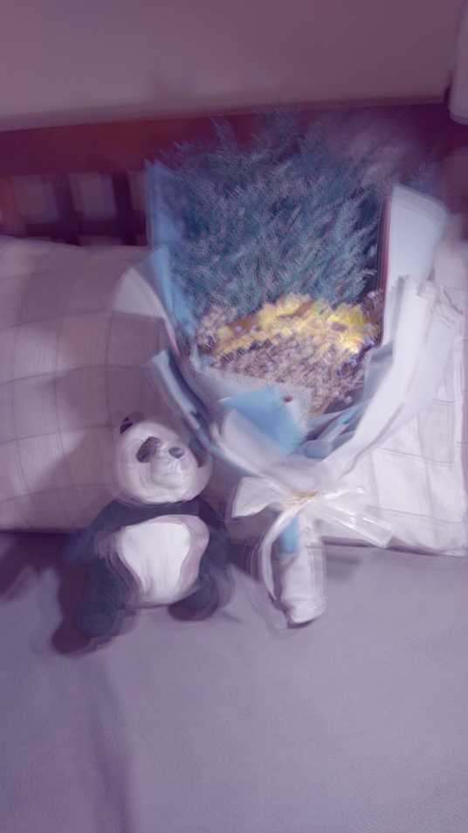

Figure10 w/ WB + LocalTM (bi)

Figure8 w/ WB

Figure9 w/ WB + LocalTM (gau)

Figure7 w/o WB

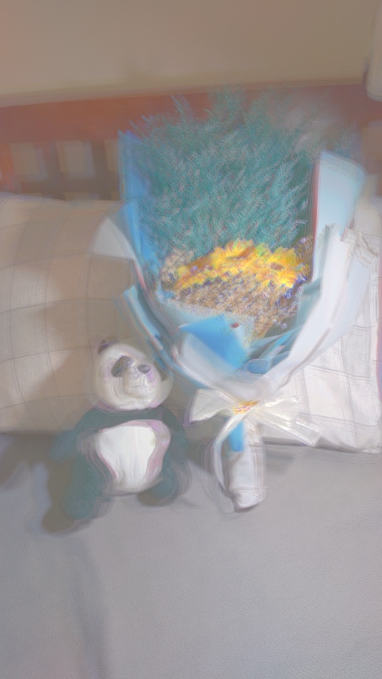 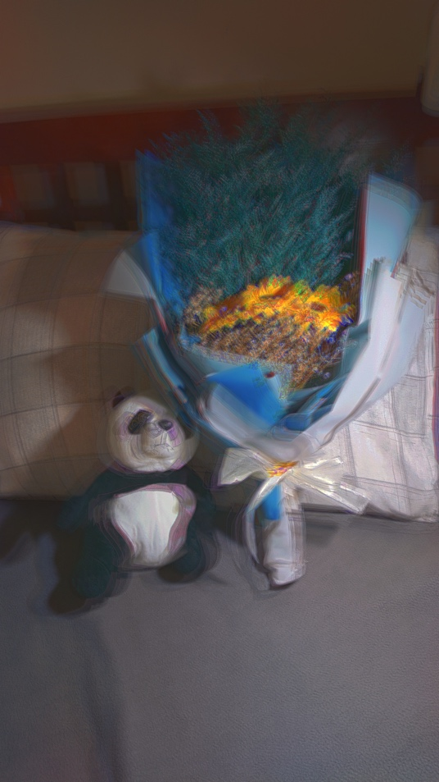

Figure12 w/ WB + LocalTM (bi, gamma=5)

Figure11 w/ WB + LocalTM (bi, log_scale)

Due to poor performance, I took another set of HDR bracketing image, here I also choose the place with strong light contrast. As we can see in Figure7,8, the image of global tone mapping becomes better.

Here I also try different setting of gamma correction(log_scale in Figure11), which shift the pixel value to higher value thus lead to brighter result.

And here I also try to adjust higher gamma value, lead to steeper intensity curves, emphasizing the differences between darker and lighter areas in the image. This increased contrast helps to bring out details and enhance the overall clarity of the image.

**2.2 Research Study (30%)**

1. In the objective function Eq. (1), the author apply a response curve assumption: the smoothness term which constrains the curve shape. Propose your idea to explain why this assumption reasonable and what will happen if we ignore the assumption. Then justify your ideas by experiments. (10%)

Assumption

During camera response calibration, we will try to minimize the objective function. And in the objective function, the smoothness term contains g′′(z), which resulting the objective function:

$$g^{''}\left(z\right)={\left(g^{'}\left(z\right)\right)}^{'}{=\left(\frac{g\left(z\right)-g\left(z-1\right)}{∆z}\right)}^{'}{=\left(\frac{g\left(z\right)-g\left(z-1\right)}{z-\left(z-1\right)}\right)}^{'}$$

$$={\left(g\left(z\right)-g\left(z-1\right)\right)}^{'}=\frac{\left(g\left(z+1\right)-g\left(z\right)\right)-\left(g\left(z\right)-g\left(z-1\right)\right)}{∆z}$$

$$=g\left(z+1\right)-2g\left(z\right)+g\left(z-1\right)=0$$

By the definition of the second order differential, it means that the difference of slope equals 0. By adding this objective function can make the line monotonically increasing in the relation between exposure and pixel value.

If we ignore this curve assumption, the curve won’t be constrained to what we want (smooth line) because we have more equation than our variables, and the irregular graphics may appear.

Justification

Here I plot the result by setting all the smoothness term parameters to 0 (to assume no smoothness term). As we can see, Figure13,14 is the radiance of original setting, where Figure 15,16 are the result w/o smoothness term.

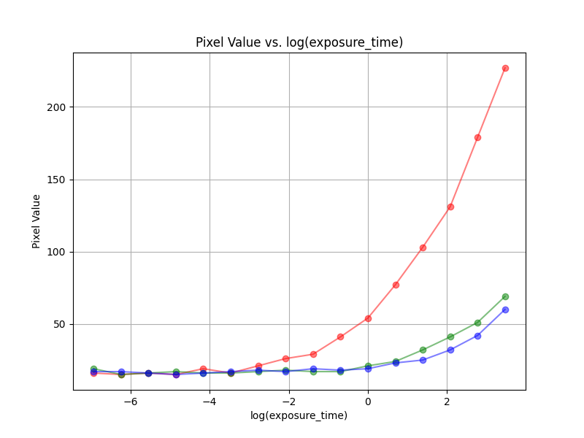 

Figure14

Figure13

w/o smoothness term

Without smoothness term (Figure15, 16), the **radiance curve become messier than before just as our previous assumption because it’s lack of constraint and may be overfitting**.

The messier radiance curve observed without the smoothness term reinforces the importance of incorporating constraints on curve smoothness in the optimization process. By enforcing smoothness, we can promote visually appealing, realistic, and artifact-free image rendering, enhancing the overall quality of the output images.

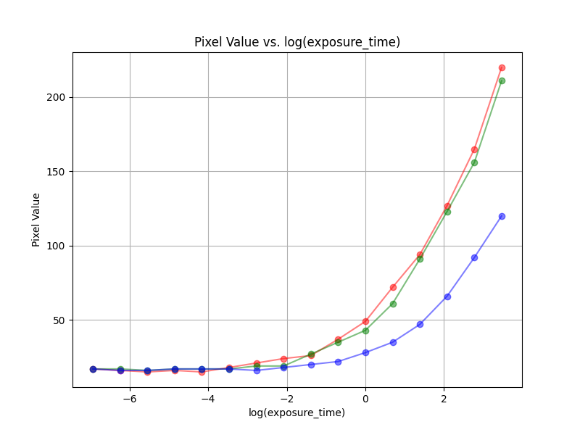 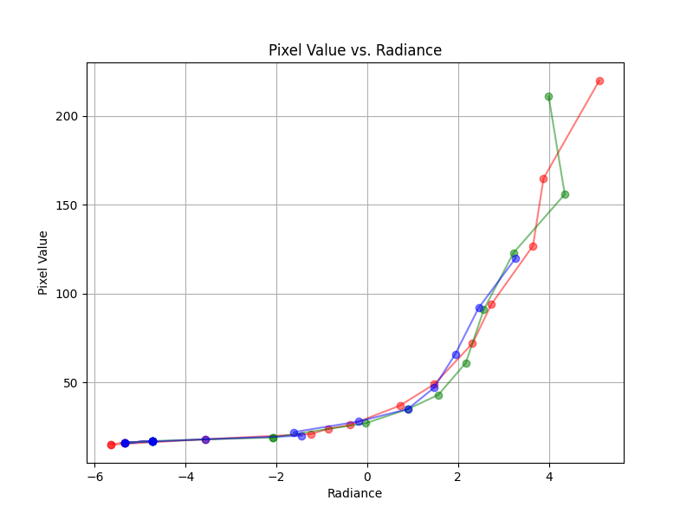

Figure16

Figure15

1. In the tone mapping parts, following the application of gamma correction to convert linear RGB to a nonlinear color space, the data is further transformed into the 0-255 domain through a series of steps: clipping to the range [0,1] → multiplication by 255 → rounding to integers. Note that during the ”clip to [0,1]” step, numerous pixels may become saturated to 1, potentially resulting in bad visual outcomes.

Are there alternative methods for transforming the data into the 0-255 domain that might yield better results? If so, suggest your own algorithm.

First, I draw the resulting histogram of default setting (after global tone mapping), here we can see that most of the value is between 50~150, and there’re some maximum value ​​clustered around 255, so we must handle this large value:

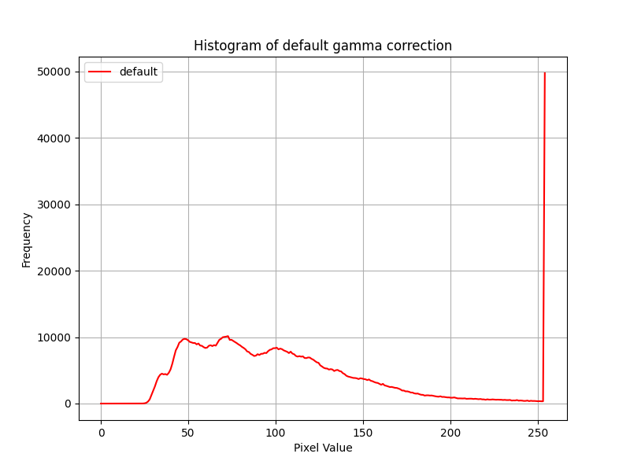 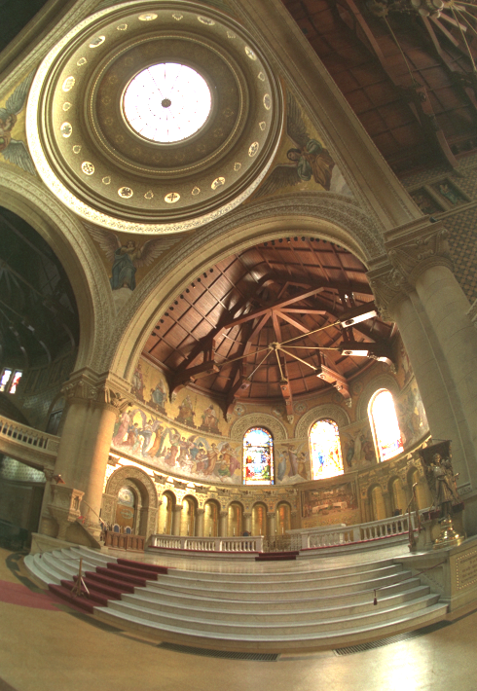

Figure18

Figure17

Here I try 2 different settings: histogram stretching and logarithm scaling.

* 1. Histogram stretching: the first idea comes up with my head, just simply span the value to its dynamic range, I expect it will enhancing the contrast and improving the overall visual quality. This can be achieved by linearly scaling the pixel values to cover the full range from 0 to 255.However, as we can in the Figure19, 21, because we have lots of outliers cluster around 255, if we directly apply this method, it will be **vulnerable to outliers**. This method will compress all the value to low pixel value. Thus, lead to a dark image just like Figure21.
  2. Logarithm scaling: This method involves taking the logarithm of the pixel values, scaling them to cover the desired dynamic range, and then mapping them back to the 0-255 range. It potentially results in **better visual outcomes compared to traditional methods** because it can deal with large number in the pixel value. As a result, it can provide a better result of HDR image.

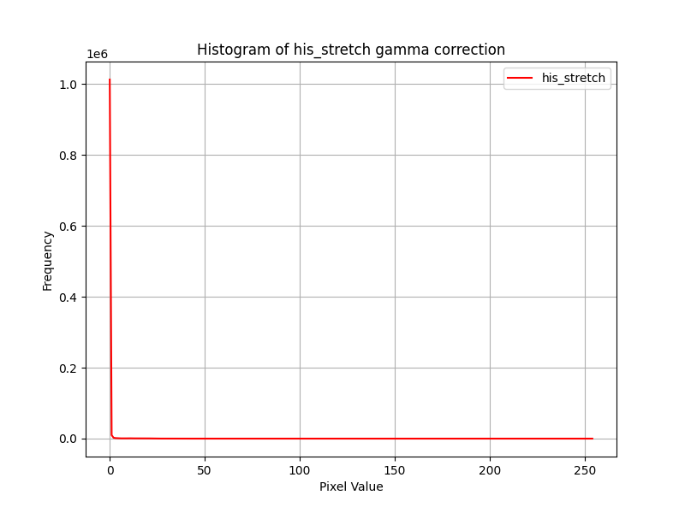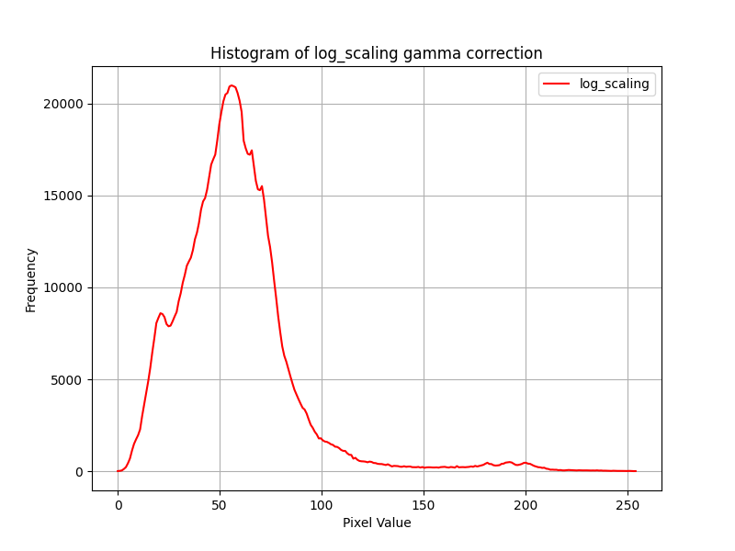

Figure20

Figure19

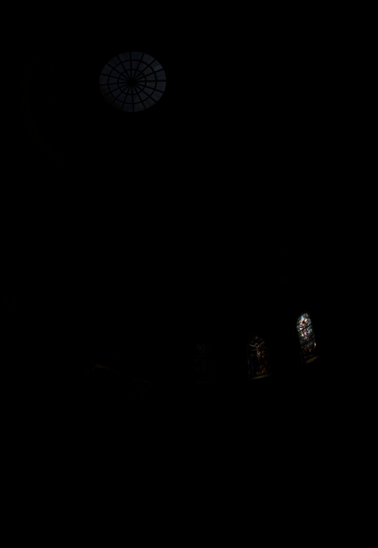 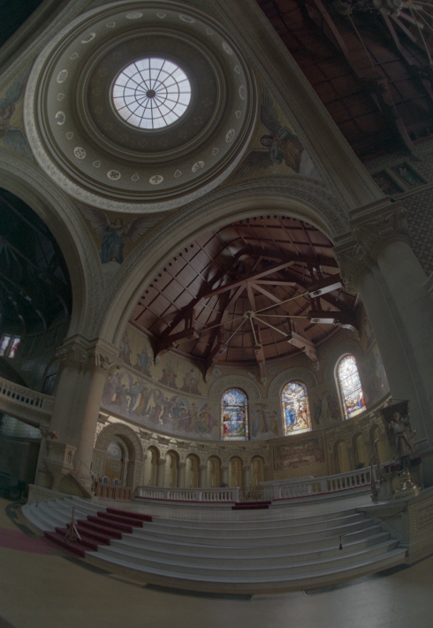

Figure22: log scaling

Figure21: histogram stretch

Overall, exploring these alternative methods for transforming the data into the 0-255 domain could potentially mitigate the issue of pixel saturation and result in improved visual quality. **From my inspection,** **log scaling performs well in our memorial case**. Experimenting with different algorithms and evaluating their performance on a variety of images would be necessary to determine the most effective approach for a given application.

1. At the step of white balance in sec 1.2, we fix the R channel value and modify G, B channel value. Can we fix G or B channel value and modify the other two channels instead? How dose different reference channel (fixed channel) affect the result HDR image? Propose your assumption and reasons. Then justify your ideas by experiments. (10%)

Assumption:

The choice of the reference channel can indeed **affect the result HDR image**, particularly when using **global tone mapping**. This is because global tone mapping techniques often rely on statistical properties of the image, and these properties can be influenced by the choice of reference channel.

On the other side, local tone mapping will not be affected because it’s adaptable to variations in image content and color balance, I prove it below.

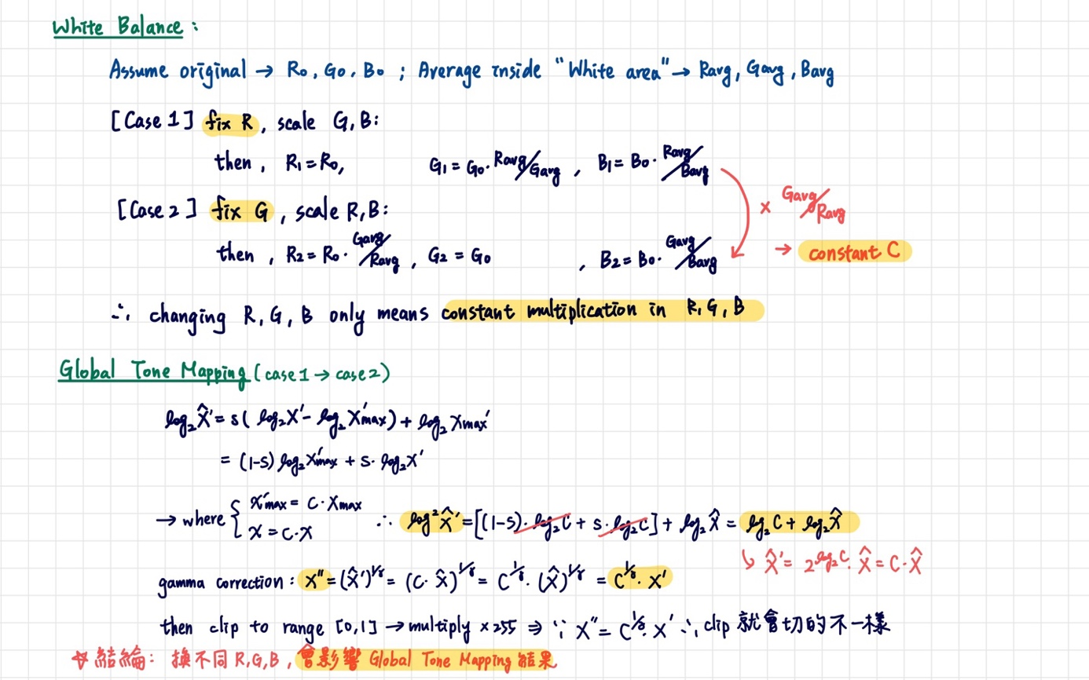

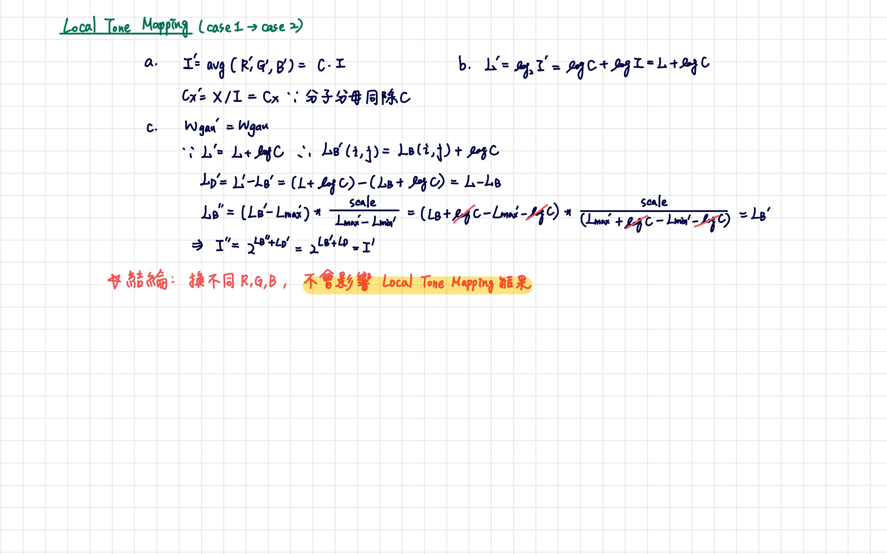

Justification:

To justify these ideas by experiments, I draw the histogram plot under different white balance setting:

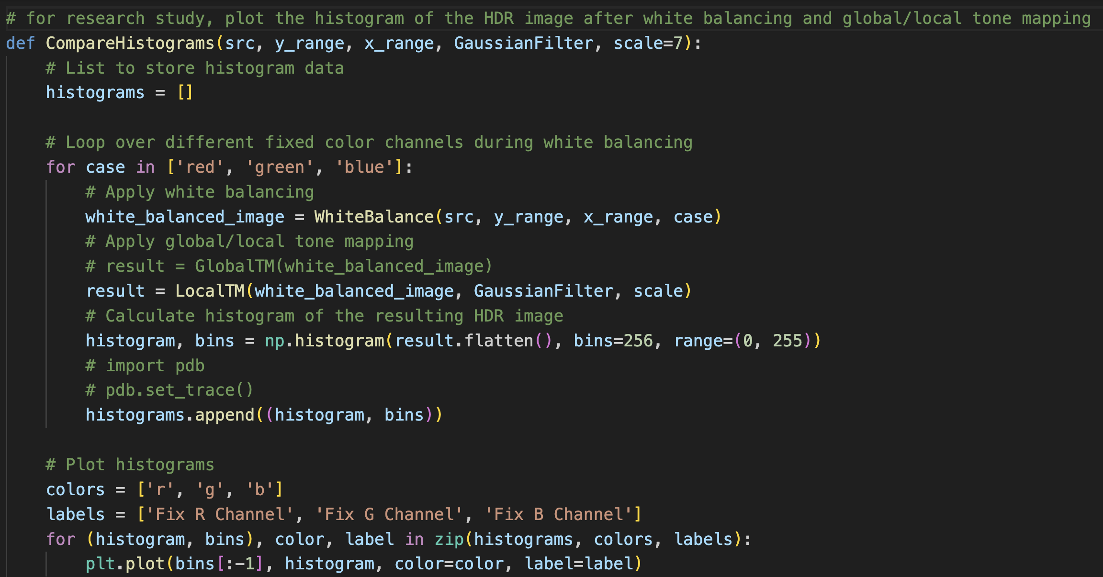

Here’s the resulting histogram of global tone mapping and local tone mapping (Figure23 and Figure24,25,26) to the resulting HDR images obtained from different white balance settings.

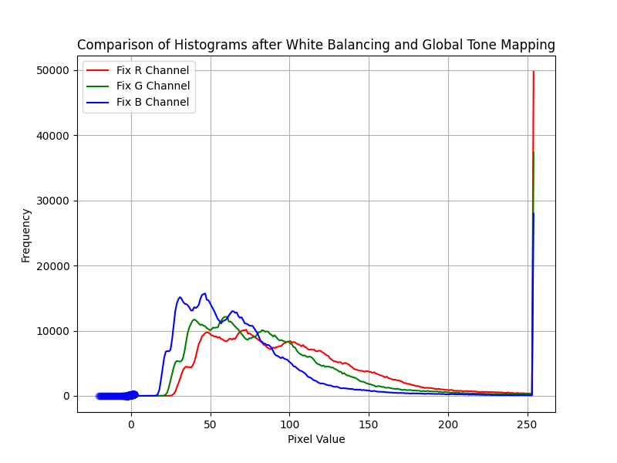 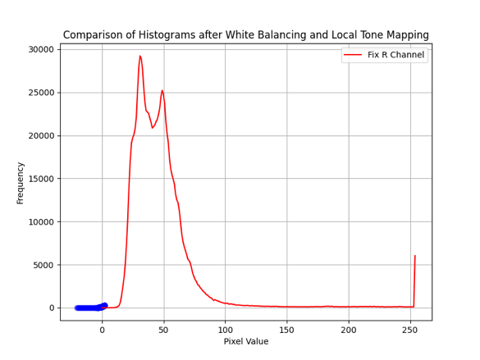

Figure24

Figure23

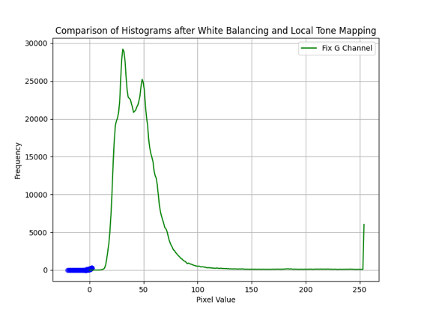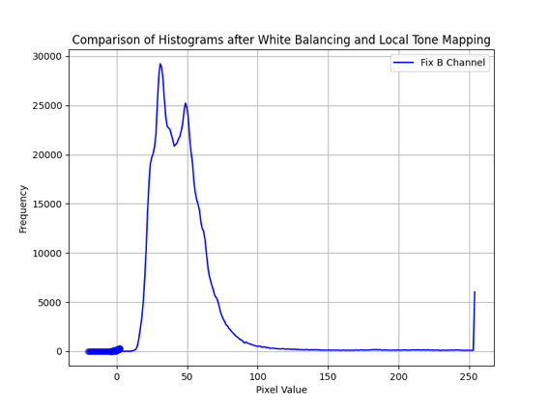

Figure26

Figure25

We observe variations in the histogram values of the Global Tone Mapping under different settings. This confirms our assumption that Global Tone Mapping might be influenced by the rendering of cool tones, potentially affecting the overall mood of the image.

Conversely, the **histogram of Local Tone Mapping remains consistent**. To elucidate this, I plotted it independently and examined the histogram values for a clearer understanding. This outcome aligns with our initial assumption that Local Tone Mapping is adaptable to changes in image content and color balance, reinforcing the idea that it remains unaffected by variations in the rendering of cool tones.

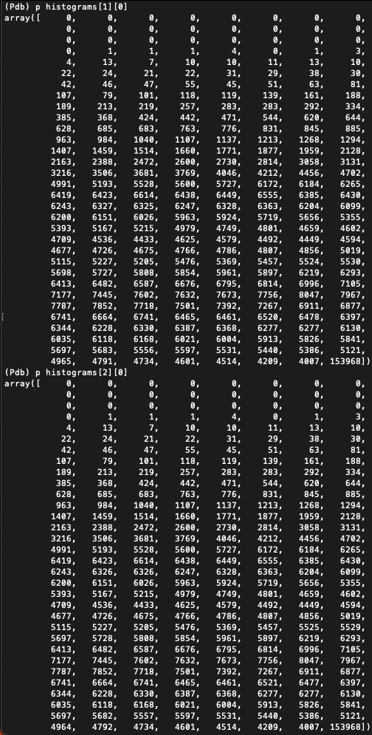 

By conducting these experiments and analyses, we can gain insights into how different reference channels affect the quality and characteristics of the resulting HDR images, particularly in the context of global tone mapping.

Appendix (Original image bracket):

1. Delta entrance

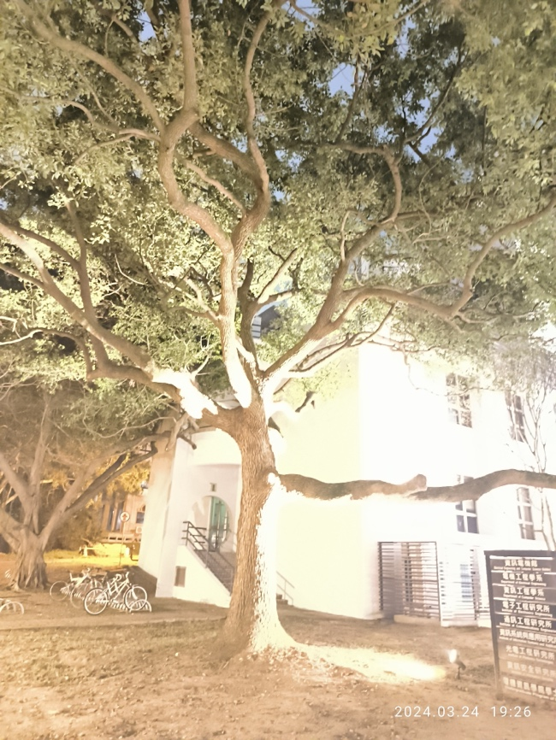 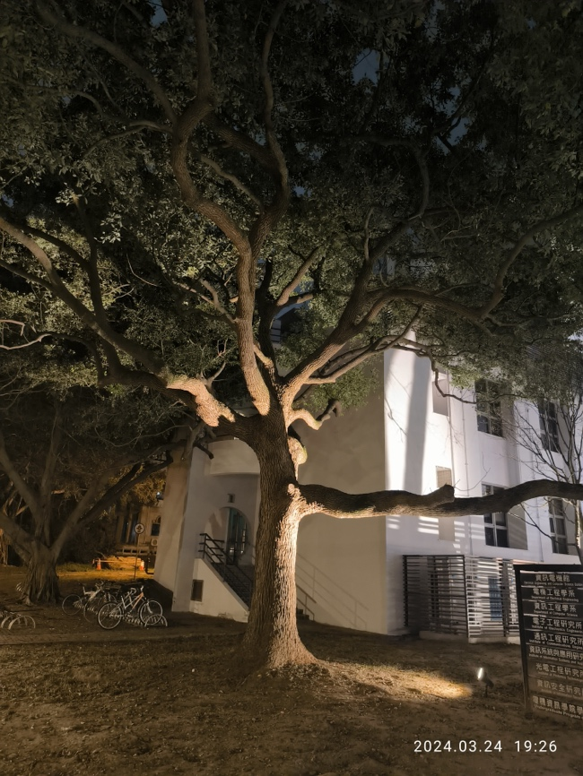

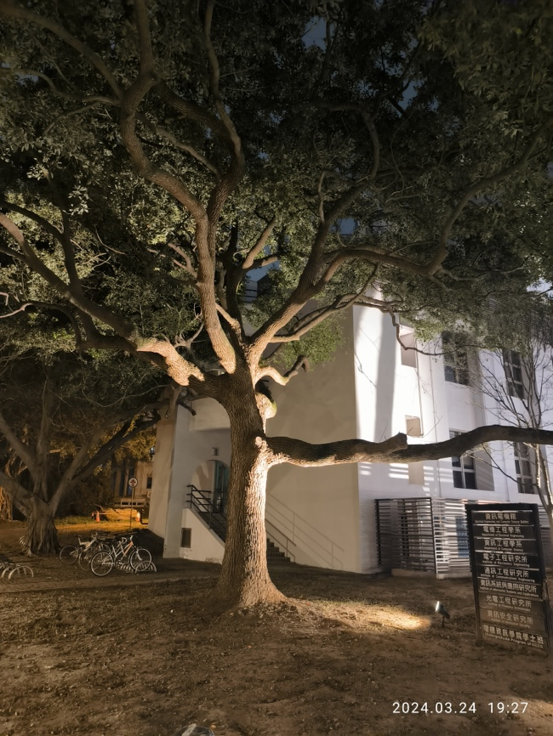 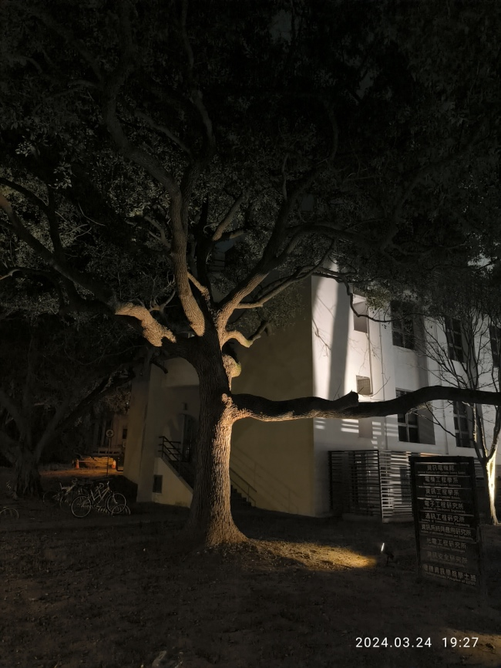

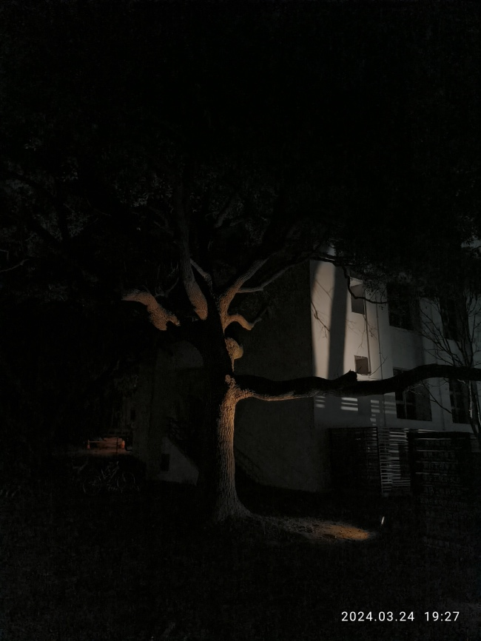 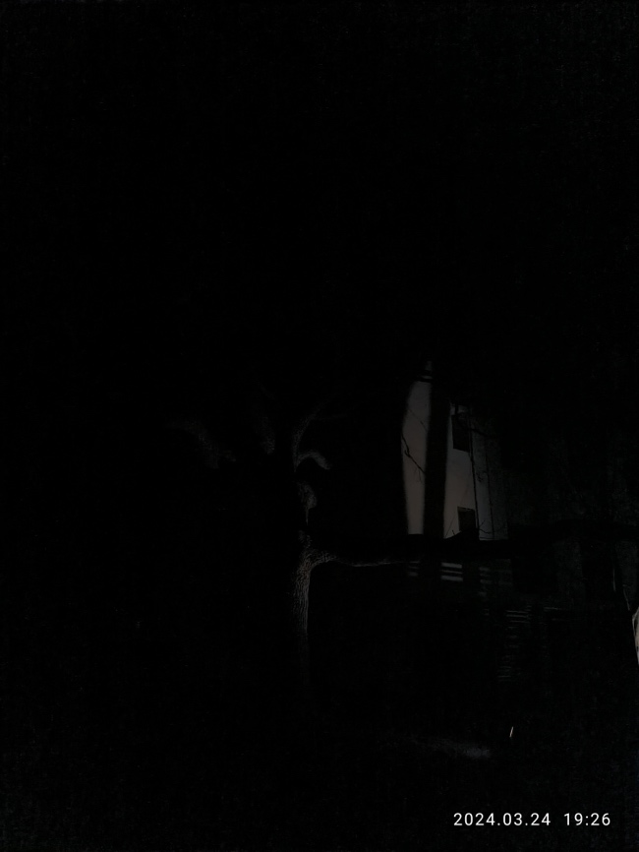

1. Indoor room

 

